ERD

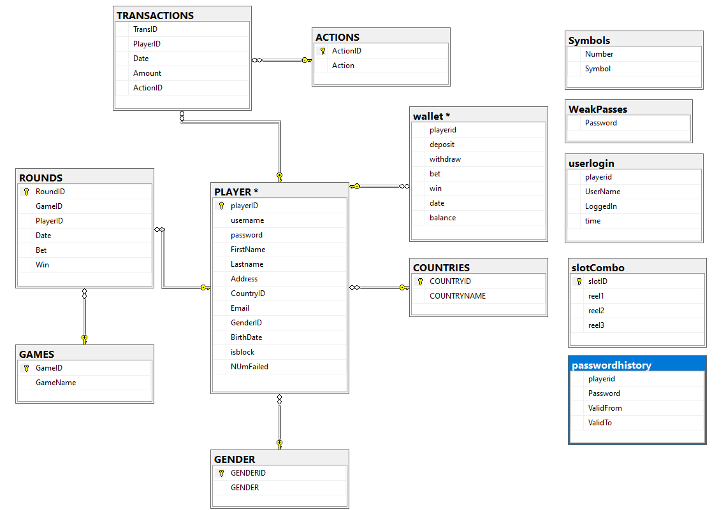

1. Player data was created in excel based on football players and passwords were auto generated and data was loaded into ssms.
2. Countries were loaded into ssms using excel from a database acquired from github.
3. WeakPasses – represents weak passwords from the git file which contained compromised passwords.
4. Slot combo - was auto generated in excel though the combinations were not used in the end

Thank you